**1. List countries with income level of “Upper middle income”**

Within this dataset, there are a total of 55 countries with an income level of ‘Upper middle income’.

**2. List countries with income level of “Low income” per region.**

There are a total of 27 countries with an income level of ‘Low income’. There are 23 ‘Low income’ countries in the ‘Sub-Saharan Africa, 2 are in the ‘Middle East & North Africa’ as well as 1 country in each of the ‘South Asia’ and ‘East Asia & Pacific’ regions.

**3. Find the region with the highest proportion of “High income” countries.**

North America has the highest proportion of ‘High income’ countries. With all 3 countries within North America having an income level of ‘High income’.

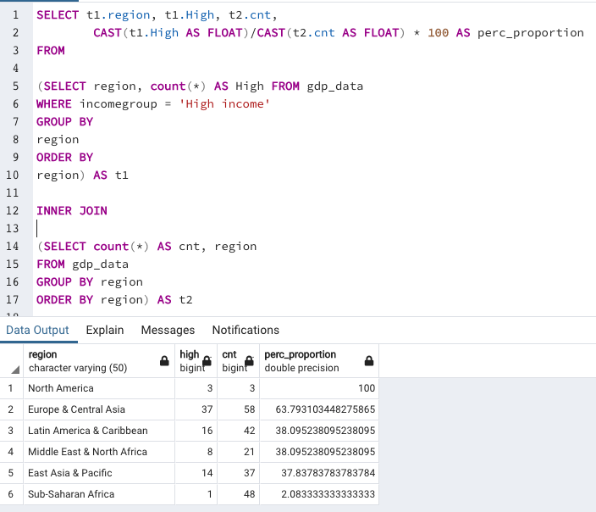

**4. Calculate cumulative/running value of GDP per region ordered by income from lowest to highest and country name.**

Using 2017 as the baseline, the cumulative GDP has been calculated per region and ordered from lowest to highest. I have assumed that a running total is to be displayed starting form the country with the lowest GDP for each region. We can use the PARTITION BY clause with the OVER clause to specify the column on which we need to perform the aggregation. In this case we want to perform a running total for each region, therefore partitioning by region, and ordering countries from lowest GDP to highest GDP. I have also included a COALESCE clause to treat NULL values as zero.

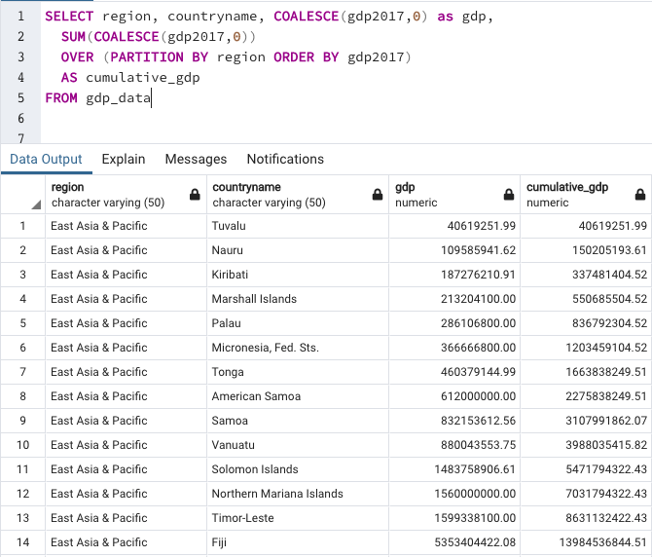

**5. Calculate percentage difference in value of GDP year-on-year per country**

The percentage difference in GDP value has been performed for each country from the available data. In some instances, it was not possible to calculate the percentage difference due to NULL values, hence the NULL values seen in below.

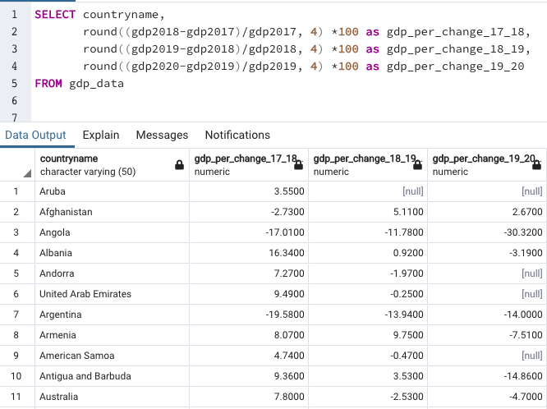

**6. List 3 countries with lowest GDP per region.**

Using the year 2017 as a baseline, I used the RANK() to define the rows in the dataset in conjunction with the OVER and PARTITION BY clause to define the subset of data to partition i.e. the region, and subsequently ordered these values by GDP value started from the lowest. I then added a WHERE filter to only display the lowest 3 countries in terms of GDP.

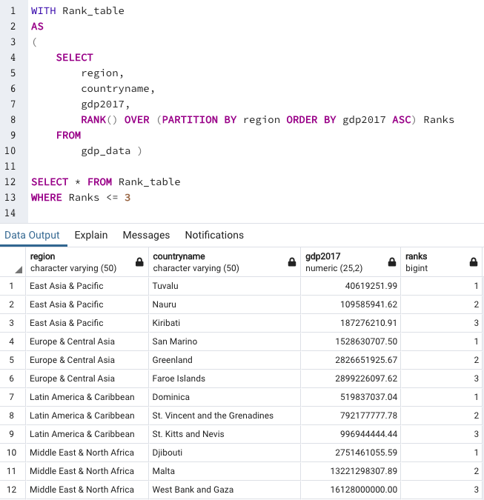

**7. Provide an interesting fact from the dataset.**

By totalling the GDP over the course of 2017-2020, China accounted for approximately 57% of the total GDP in the East Asia & Pacific region out of 37 countries in total.

